Department of Computer Science and Engineering

CSE-1004 Fundamentals of Electrical and Electronics Engineering
Title of Experiment
Verification of Thevenin's theorem

Name of the Student | Rajyavardhan Singh Bais
Scholar Number | 26U020032
Due Date of Submission: |  | Date of Submission:

Assessment Rubrics
Description | Mark Allotted | Mark Secured
Apparatus required and Important definitions | 10
Experimentation: Connection, Conduction and Verification | 35
Theoretical Calculations | 25
Results and Inference | 10
Viva questions | 20
Late Submission/Plagiarism Mark Deduction | 10
Total Marks | 100

Signature of Lab in-charge

Activity Sheet
Verification of Thevenin's theorem

AIM:
To verify Thevenin’s theorem by determining the Thevenin equivalent voltage (V_{th}) and Thevenin equivalent resistance (R_{th}) of a given linear electrical circuit and comparing the theoretical values with experimental results.

CIRCUIT DIAGRAM
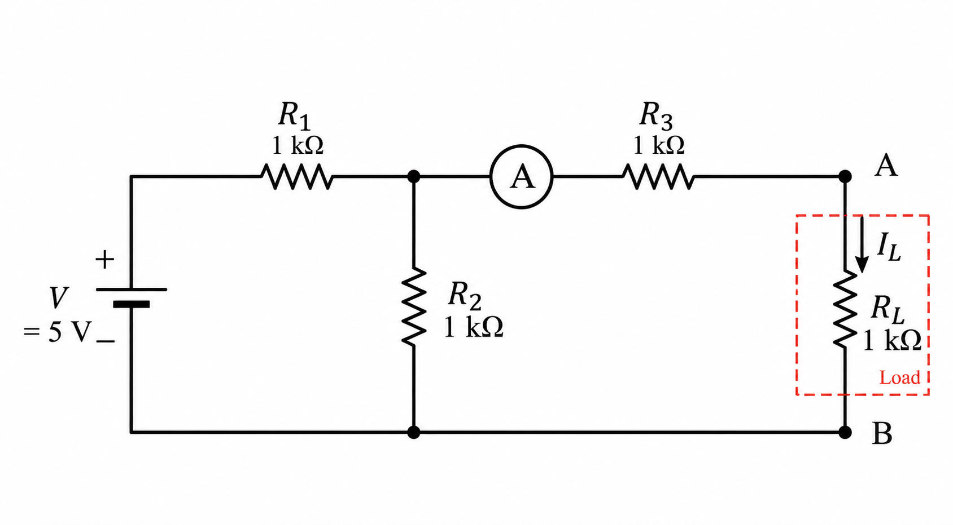

LIST OF THE COMPONENTS AND EQUIPMENT:
S. No. | Device/ Equipment | Range/Rating | Quantity in No.
1. | Multimeter | 200mV-600V; μ-10A | 1
2 | Jumpwires | - | 3-4
4 | Breadboard | - | 1
5 | Resistors | 1k ohm | 4
6 | Constant DC Supply | 0-10V | 1
7.

EQUIPMENT LEARNING:
The regulated power supply provides a stable DC voltage to the circuit. The digital multimeter is used to measure voltage, resistance, and current. The resistors and connecting wires are used to construct the circuit and verify Thevenin’s theorem.

THEORY:
Any linear bilateral electrical network containing voltage sources, current sources, and resistors can be replaced by an equivalent circuit consisting of a single voltage source (Thevenin’s voltage, V_{th}) in series with an equivalent resistance (Thevenin’s resistance, R_{th}), connected to the load.
- Thevenin’s Voltage (V_{th}):
It is the open-circuit voltage measured across the load terminals when the load resistance is removed from the circuit.
- Thevenin’s Resistance (R_{th}):
It is the equivalent resistance of the network seen from the load terminals with all independent voltage sources replaced by short circuits and independent current sources replaced by open circuits.
- Thevenin Equivalent Circuit:
Once V_{th} and R_{th} are determined, the original circuit can be replaced with a simple two-element series circuit consisting of V_{th} in series with R_{th} and connected to the load resistance (R_{L}).
This theorem simplifies the analysis of complex circuits, particularly when the response of the circuit is required for different values of load resistance. Instead of analyzing the entire network again, only the simple Thevenin equivalent needs to be considered.
PROCEDURE:
- Connections are given as per the circuit diagram.
- Set a particular value of voltage using RPS and note down the corresponding ammeter readings.
- Remove the load resistance and measure the open circuit voltage using a multimeter (V_{th}).
- To find Thevenin’s resistance, remove the RPS and short-circuit it, and find the
R_{th} using a multimeter.
- Give the connections for the equivalent circuit, set V_{th} and R_{th}, and note the
corresponding ammeter reading.
- Verify Thevenin's theorem.
OBSERVATION:

 | RPS | V_{th} (Volt) | R_{th} (Ohm) | I_{L} (A)
Theoretical | 5V | 1V | 1.5K ohm | 1mA
Practical | 4.97V | 0.99V | 1.463 ohm | 0.99mA

PRECAUTIONS:
- The voltage control knob of the RPS should be kept in the minimum position.
- The current control knob of RPS should be kept at the maximum position.

ANALYTIC ANALYSIS AND SIMULATION:
The Thevenin equivalent circuit is obtained by calculating the open-circuit voltage across the load terminals and the equivalent resistance seen from those terminals. The load current is then calculated using:
I_{L}= V_{th}/{R_{th}+R_{L}}
The theoretical results are compared with the experimental readings to verify Thevenin’s theorem.
INFERENCES:
• The Thevenin equivalent circuit simplifies a complex linear network into a voltage source in series with an equivalent resistance.
• The load current depends on the Thevenin voltage, Thevenin resistance, and load resistance.
• The theoretical and experimental values should be approximately equal, with small differences caused by component tolerances and measurement errors.
RESULTS:
• Thevenin’s Voltage V_{th}: Theoretical: 1V; Experimental: 0.99V.
• Thevenin’s Resistance R_{th} Theoretical: 1.5k ohm; Experimental: 1.463k ohm.
• Load Current I_{L}: Experimental reading: 0.99mA as recorded. The theoretical current calculated from the listed values is 1mA.
LEARNING FROM THE EXPERIMENT:
The experiment demonstrates how a complex electrical network can be replaced by its Thevenin equivalent without changing the behaviour observed at the load terminals. It also provides practical experience in measuring voltage, resistance, and current using a digital multimeter.
Lab activity:
Q1. Find Thevinin’s equivalent circuits of the given circuit:
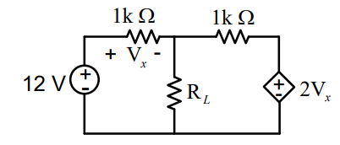
Q2. Find the Thevenin’s equivalent for the circuit shown in the given Figure with respect to terminals a-b.
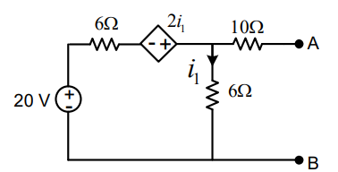
Q3. Determine the current through the load resistance using Thevenin’s theorem for the circuit shown in Figure.
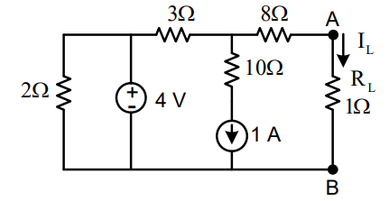

Viva Questions
Q1. What is the practical importance of Thevenin’s theorem in electrical circuits?

Q2. How can Thevenin’s theorem help in designing household electrical systems or appliances?

Q3. In communication circuits, why would an engineer use Thevenin’s equivalent instead of analyzing the whole network?

Q4. If a mobile charger is considered as a source, how can Thevenin’s theorem help understand charging efficiency?

Q5. What are the limitations of Thevenin’s theorem in real-life systems?

